What this describes is a set of expressions and associated code. When the first expression reached evaluates to true, the associated code is executed. In summary, that is what TeamWorks rules describe. The rules allow us to build expressions based on the values of a set of variables that are in scope. A table is visually constructed. The columns in the table represent the variables and the rows represent possible values for those variables. The rows are then evaluated at runtime from top to bottom and if the overall expression evaluates to true, the associated JavaScript code is executed. Commonly that JavaScript code will assign a value to another variable.
When a Decision Table is added to the canvas, it looks as follows.
这描述了一组表达式和相关代码。当达到第一个表达式的求值结果为true,相关的代码执行。总之,这就是TeamWorks规则描述。规则允许我们建立表达式基于一组变量的值的范围。一个表是视觉构造。表中的列代表变量和行代表可能的变量的值。行然后在运行时从上到下进行评估,如果整个表达式计算为 true,执行相关的JavaScript代码。通常,JavaScript代码将分配一个值到另一个变量。
当一个决策表添加到画布上,它看起来如下。
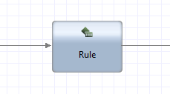
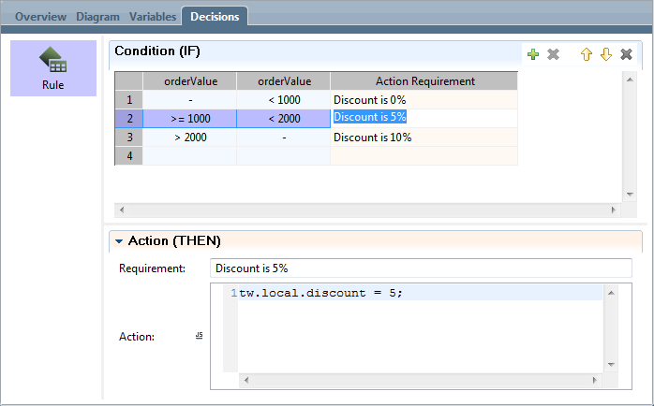
Pattern matching
A special pattern of "-" (just the dash character) can be used to match any pattern. It is a wild card.
Strings
模式匹配
一个特殊的模式“-”(dash字符)可以用来匹配任何模式。这是一个通配符。
字符串
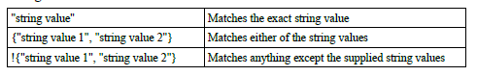
数字
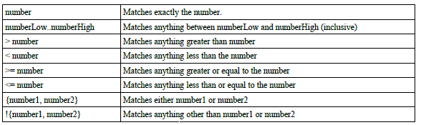
布尔
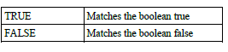
Integrating with WODM
和WODM整合
In addition to the previous options, we can also integrate with an instance of WODM. The first task is to define the location of the Rule Execution Server to the Process App. In the Process App Settings we can define a new server of type "ILOG Rules Server" and define the hostname and port on which it can be found:
除了前面的选择,我们也可以集成WODM的实例。第一个任务是定义规则执行的位置服务器应用的过程。在这个过程中我们可以定义应用程序设置一个新的服务器类型的“JRules Decision Service”和定义可以发现的主机名和端口:
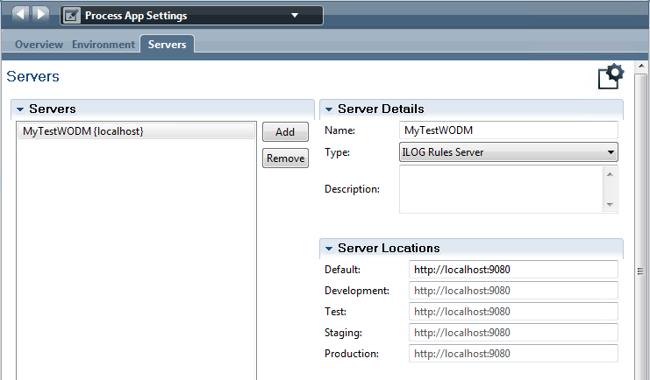
By dragging a component called "JRules Decision Service" into the canvas area we can connect to WODM.
See also:
• WebSphere Operational Decision Management - WODM
通过拖动组件称为“JRules Decision Service”我们可以连接到WODM到画布区域。
另见:
• WebSphere Operational Decision Management - WODM
Service Components
Definitions of services exist as part of a Process Application. Each definition for of a service has a name and associated "coding". The service is "associated" with a BPD activity in a BPD process diagram. The service can either be created (from new) from the BPD activity or an existing service can be "linked" to that activity. The definition of the service is an "implementation" part of the solution.
Similar to a BPD, a Service has its own visual editor and palette:
服务组件
定义服务的存在作为流程应用程序的一部分。每个服务的定义有一个名称和相关的“编码”。服务BPD“关联”BPD在一个BPD流程图中。服务可以被创建(新)BPD活动或现有的服务可以“链接”活动。服务的定义是“实现”解决方案的一部分。
类似于一个BPD,一个服务有自己的可视化编辑器和面板:
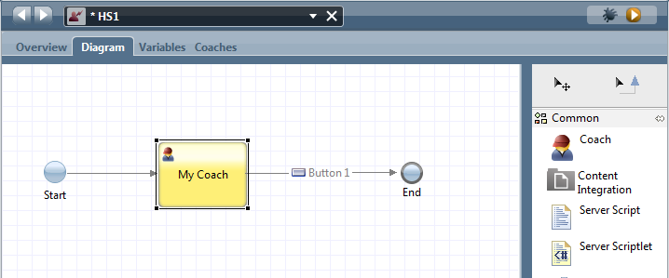
The palette is composed of the following parts some of which are only applicable to certain types of service:
面板由以下部分组成其中一些只适用于某些类型的服务:
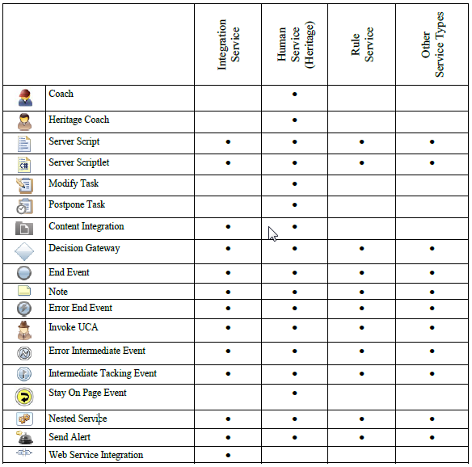
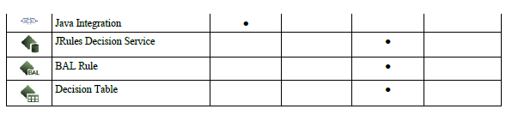
After dragging and dropping the elements onto the diagram, the elements can be visually wired together with Sequence Lines in the same fashion that BPD elements are also wired together with Sequence Lines. The remainder of this section will walk us through the different types of service components available to be included in the implementation of a service.
See also:
• Sequence Lines
拖拽元素在图后,可以视觉元素与序列行以相同的方式连接在一起,BPD元素也与序列线路连接在一起。本节的其余部分将指导我们完成不同类型的服务组件可以包含在一个服务的实现。
另见:
•序列行

Coaches
界面
When added to a Heritage Human Service diagram, the Coach looks as follows:
From the palette, the icon is:
当添加到传统人服务图,界面看起来如下:
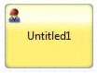
从调色板中,图标:
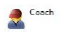

The idea of a Coach is that it describes a screen layout that is to be shown to a user. The screen will contain output data that is populated and shown to the user as well as input data that can be entered by the user and returned to the service. Coaches are such an important area of IBPM that they have their own section in the book found here:
• User Interfaces and User Interaction
界面的想法是,它描述了一个屏幕布局将呈现给用户。填充屏幕将包含输出数据,并显示给用户,以及输入数据用户输入和服务返回。界面在IBPM如此重要的地区,他们有自己的部分在书中发现:
•用户界面和用户交互

Server Scripts
When added to a Service diagram, the Server Script step looks as follows:
服务器脚本
当添加到服务图,服务器脚本步骤看起来如下:
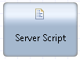
On the palette, the icon representing this step looks like:
面板上,图标代表这一步看起来像:
The purpose of this type of step is to allow the developer to enter a JavaScript fragment of code to be executed at runtime within the Process Server. The properties section of the Step provides a code entry area where the script can be coded:
这种类型的步骤的目的是让开发人员输入一个JavaScript代码片段在流程服务器上运行时执行。步骤条目属性提供了一个部分地区的用来编码脚本:

